VirtualBox Documentation Soc lab
SOC Home Lab - VirtualBox, Windows Event Logging, and ICMP Analysis
##Environment
- Host OS: Windows 11
- Hypervisor: Oracle VirtualBox
- Guest OS:
- Kali Linux 2025.2
- Windows 11
- Network Mode: Host-only Adapter
Setup:
VirtualBox was installed to create an isolated SOC lab environment consisting of Kali Linux and Windows 11 virtual machines. During initial startup, the Kali Linux VM failed to launch due to a VirtualBox kernel driver error (`VERR_LDR_IMPORTED_SYMBOL_NOT_FOUND`), commonly associated with driver or virtualization conflicts on Windows hosts.

After reinstalling VirtualBox and adjusting system virtualization settings, both virtual machines successfully booted and were prepared for network and security testing.
Result Code: | E_FAIL (0x80004005)
Component: | ConsoleWrap
Interface: | IConsole {6ac83d89-6ee7-4e33-8ae6-b257b2e81be8}

Step 1:
What I Did:
I configured both Kali Linux and Windows 11 virtual machines to use a host-only network adapter in VirtualBox. I identified each system's IPv4 address using IP a on Kali Linux and ipconfig on Windows. ICMP echo requests were then sent between the systems to verify internal network connectivity.

What I learned:
This step confirmed that both virtual machines were correctly assigned IP addresses within the same subnet and could communicate at Layer 3. Verifying connectivity early ensures that later security testing results are not caused by basic networking misconfigurations.

Purpose:
The purpose of this step was to validate network segmentation and internal communication before generating security-relevant activity, mirroring standard SOC validation procedures.
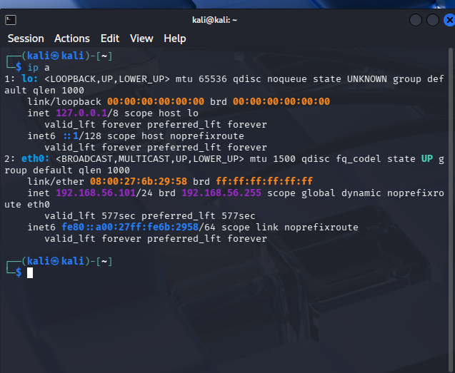
Kali Linux IP configuration (ip a):
Confirms the Kali Linux system was assigned an IPv4 address on the host-only network interface
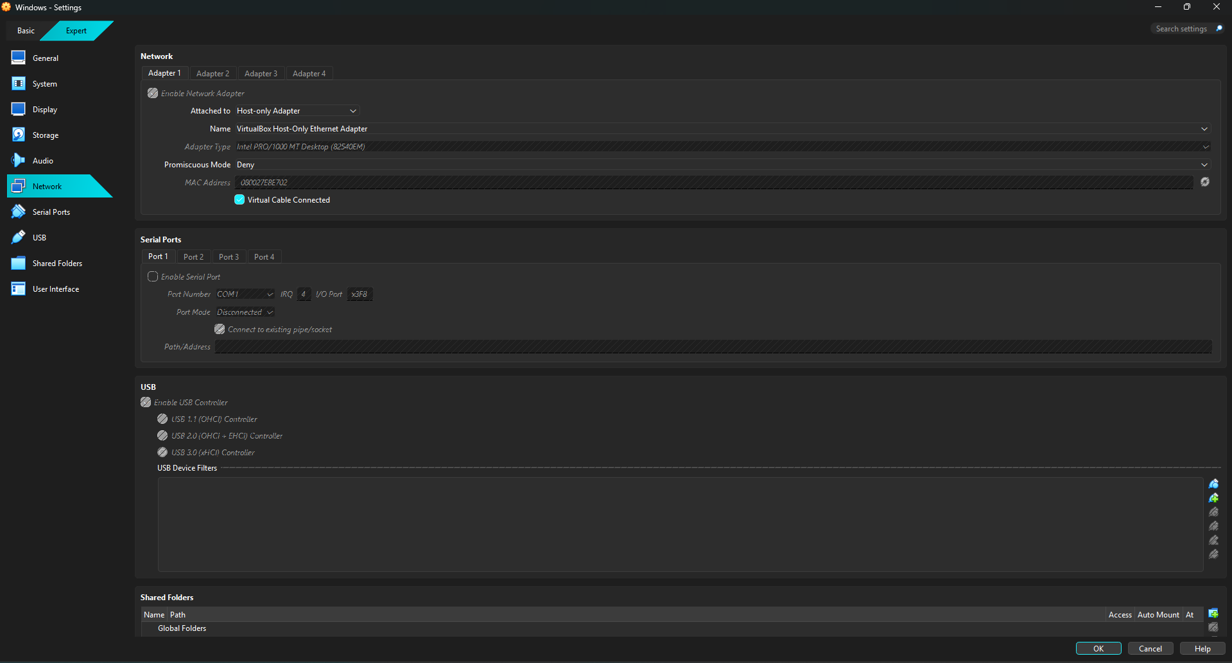
VirtualBox host-only network configuration:
Shows the virtual network adapter configuration used to isolate internal VM communication.
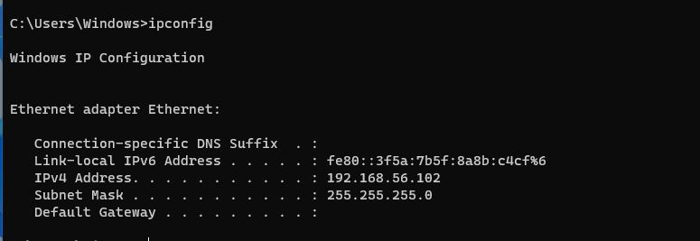
Windows 11 IP configuration (ipconfig):
Confirms the Windows system received an IPv4 address within the same subnet as the Kali Linux VM
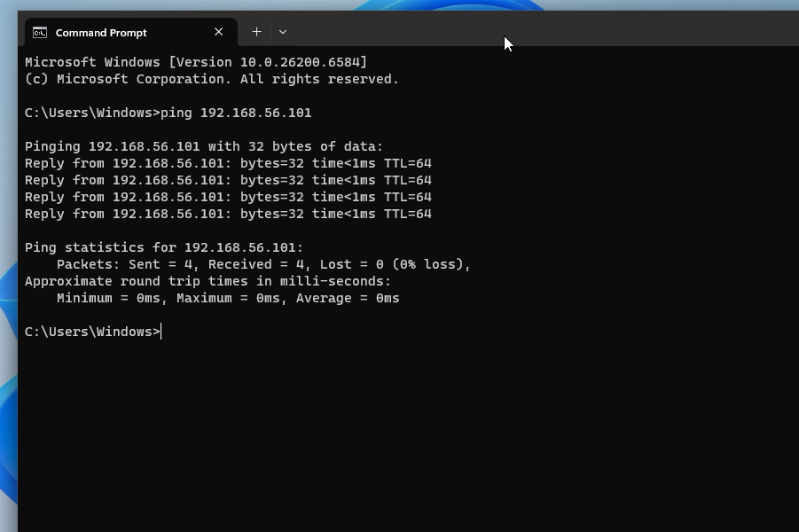

ICMP connectivity verification:
Successful ICMP echo replies confirm Layer 3 connectivity between the Windows and Kali virtual machines

Step 2:
What I Did:
I examined the Windows event viewer to understand how the operating system records system and application activity. I reviewed the system and application logs to observe service behavior, system state changes, and application events. Access to the security log required administrative privileges, which were restricted in this environment.

What I Learned:
This step demonstrated how Windows organizes event data across multiple log categories and how analysts can still extract meaningful telemetry even with limited access. It reinforced the importance of documenting access constraints during the counting analysis.

Purpose:
The purpose of this step was to simulate real- world SOC conditions where analysts may not have full administrative privileges and must rely on available logs to maintain situational awareness.
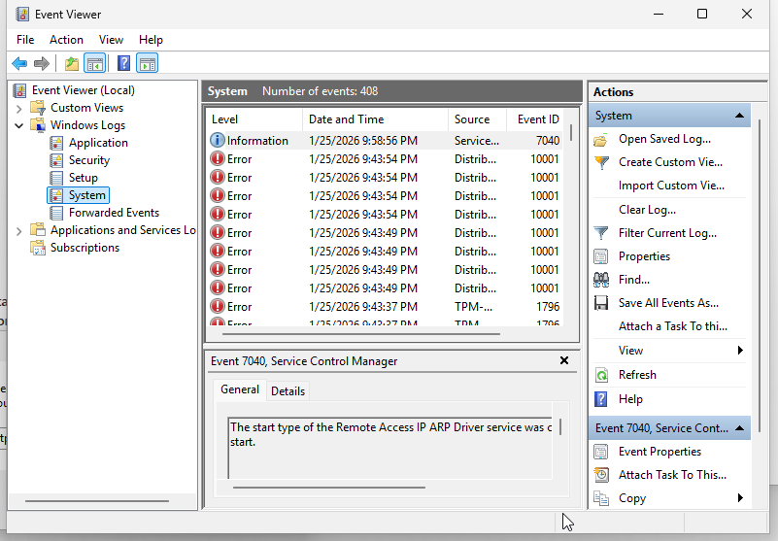
System log event inspection:
Demonstrates visibility into system-level activity such as service state changes.
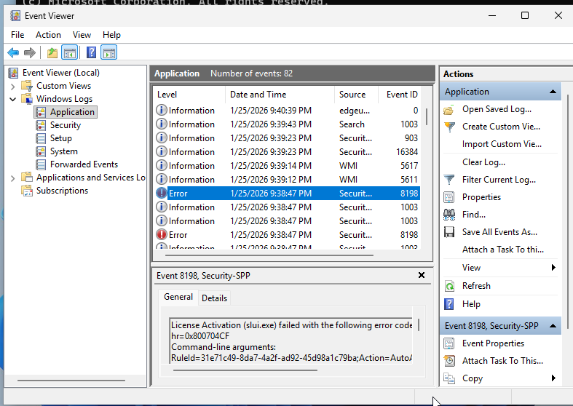
Application log analysis:
Shows application-level events that provide context during system monitoring and investigations.
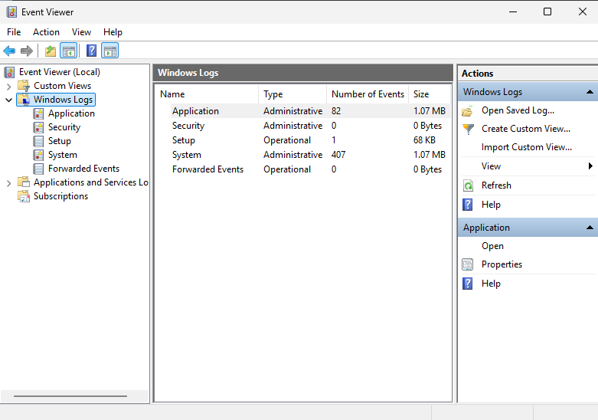
Expanded Windows Logs view:
Shows are available in log categories used during host-based monitoring.
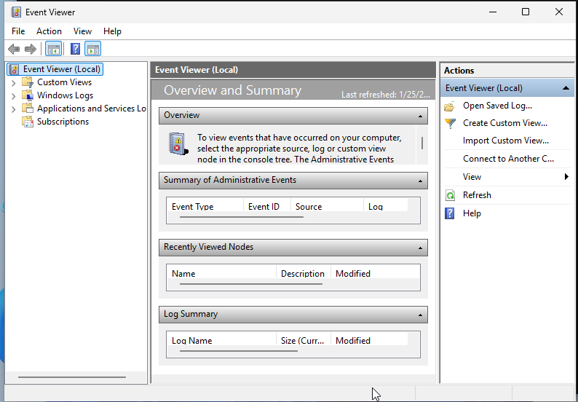
Windows Event Viewer overview:
Displays the centralized logging interface used to analyze system, application, and security events.

Step 3:
What I Did:
In step 3, controlled ICMP traffic was generated from a Kali Linux system to a Windows 11 host within a host-only virtual network. This simulated basic internal network communication in a controlled lab environment. The Windows host did not respond to ICMP echo requests due to a firewall policy, resulting in Windows firewall rules blocking ICMP echo requests. This showed me that layer 3 connectivity between hosts and validated that the host-only network was functioning as intended before generating security-relevant traffic

What I learned:
This step demonstrated that packet loss or an ICMP echo request being blocked does not necessarily indicate a connectivity issue but often reflects enforced firewall rules. It also showed that basic network traffic is not logged by default in Windows Security logs and that analysts must understand both firewall behavior and log visibility when interpreting potential security events.

The purpose:
The purpose of this topic was to reinforce that security controls can intentionally limit visibility and reachability. SOC analysts must differentiate between normal security enforcement and actual network failures or attacks by correlating traffic behavior with system logs and policy context.
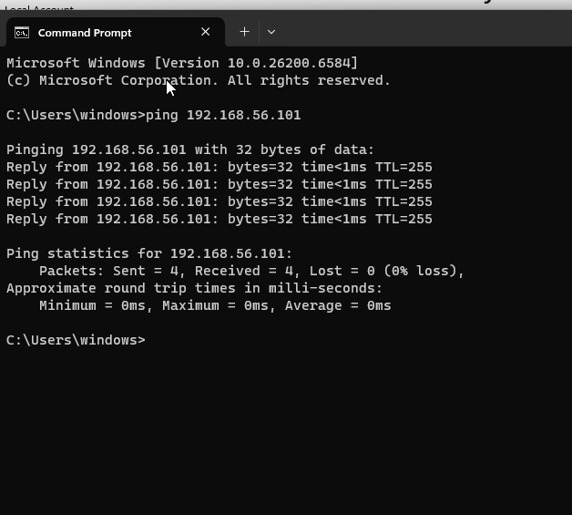
ICMP request:
Initial network reachability test initiated from Windows CLI
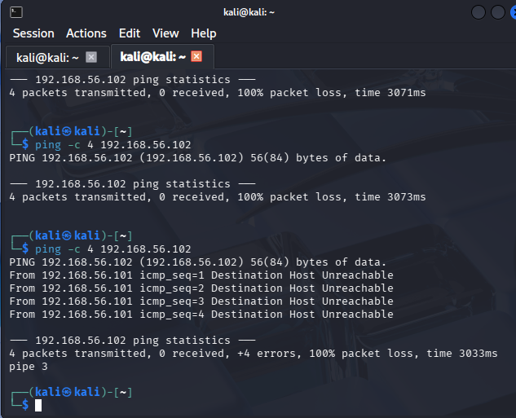
Kali ping Windows unreachable:
ICMP traffic is blocked by the firewall policy.

Step 4:

What I Did:
In step 4, repeated failed authentication attempts were intentionally generated on windows 11 system by entering incorrect credentials multiple times, followed by a successful login. Windows security logs were reviewed to identify authentication-related events associated with this behavior.

What I learned:
This step demonstrated how Windows records authentication activity using security event logs, specifically failed logon attempts (Event ID 4625) and successful logons (Event ID 4624). It showed how a pattern of failed logins followed by success can indicate either normal user behavior (mistyped passwords) or potentially suspicious activity that warrants further review.

The purpose:
The purpose of this step was to practice identifying and interpreting authentication patterns from a SOC analyst's perspective. It reinforced the importance of correlating multiple log events over time to determine whether activity represents benign user error or a potential security incident

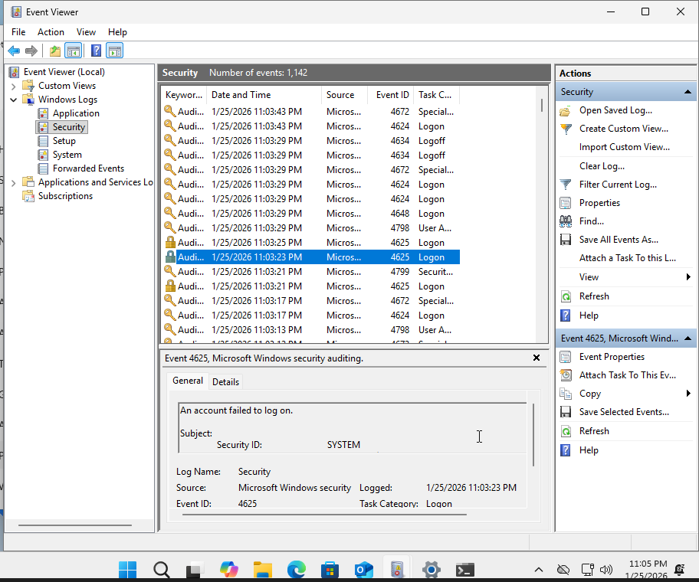
Failed logon event (Event ID 4625):
Records multiple failed authentication attempts caused by incorrect credentials. This event captures login failure details relevant to brute-force or credential misuse analysis.

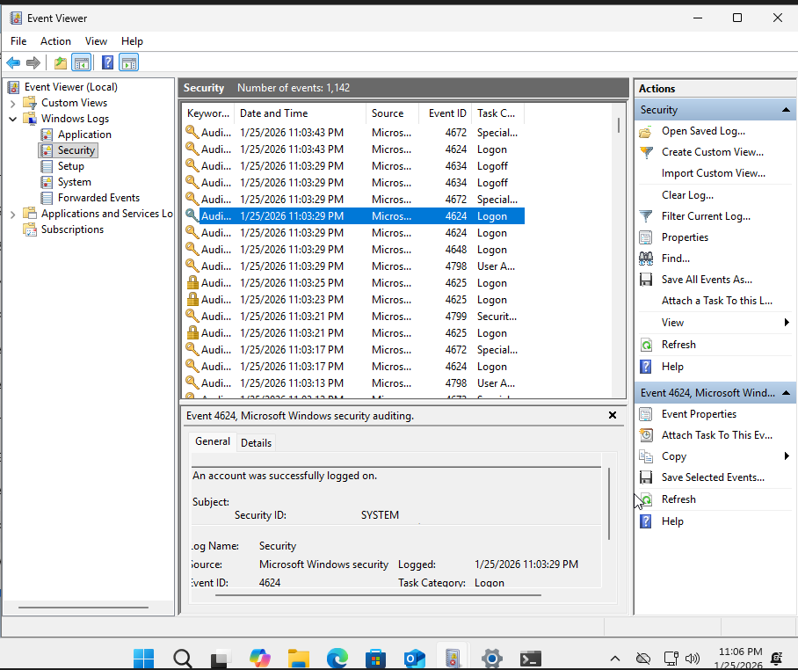
Successful logon event (Event ID 4624):
Shows successful authentication following prior failed attempts, demonstrating how correlated log events can indicate either user error or potentially suspicious access patterns.

Reviewing both failed (4625) and successful (4624) logon events reinforces the importance of correlating authentication activity over time. A sequence of repeated failures followed by success may indicate benign behavior, such as mistyped passwords, or warrant further investigation for potential credential compromise.

